# 1 An overview of the centralized networking

## First, theCentralized network planning

### 1. Outline

Huawei multimedia contact center supports centralized, distributed and networked call center network structure.

The centralized network will relay access CTI Platform, IVR Resource units, seats, and database and file Centralized servers and other equipment to a local server, isolated from the external network, reducing the risk of network attacks, and operation and maintenance costs.

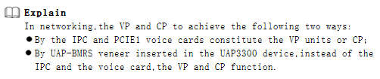

### 2. Centralized network diagram

Focus on networking , CTI, Queue, IVR, Manual seats, business systems and other equipment for centralized deployment and centralized access to headquarters. Handle all calls through the operator's network which is a business department of the local deployment of a small amount of the remote agent.

2.1NetworkMap

Through the network diagram can understand the typical networking of the centralized network.

Typical networking solutions such as centralized network Map 1 and Map 2 Follows:

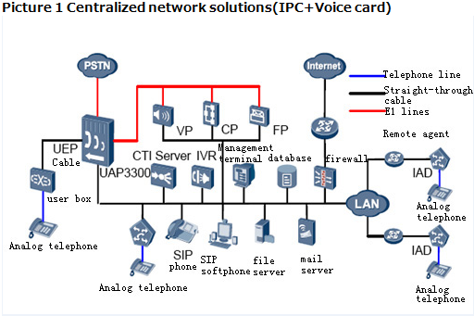

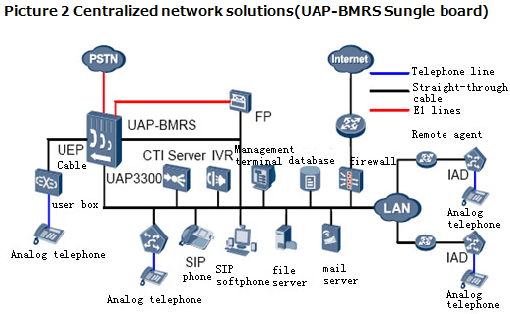

2.2Networking equipment functional description

In a centralized network, the main equipment bears different functions.

**Table A** Networking equipment functional description

|  |  |
| --- | --- |
| **Device name** | **Functional Description** |
| UAP3300 | Act as the role of the ACD is responsible for access to the user's call. |

|  |  |
| --- | --- |
| **Device name** | **Functional Description** |
| UAP-BMRS | A resource board inside UAP3300 providing VP Stations and CP Sets of functions. |
| CTI Server | Controls UAP3300 call operations through CTI Link, which communicates to UAP3300 using INTESS Huawei internal protocol, |
| VP / CP / FP | Consists of industrial computers and PCI E1 voice cards and connect to UAP3300 through E1 cables to provide voice conference and Fax resources. |
| IVR | Interactive voice response system, the operating platform of an automated business processes. |
| Management terminal | This tool can be used to perform operations on the UAP3300, such as data configuration, status monitoring, alarm management, and signaling  tracing. |
| Database | Huawei multimedia contact center has a dedicated database for maintenance of customer information data and for the management of various system statistics. |
| File server | The device stores all types of required files, such as flow files and voice recording files. These files are used during the running of the system. |
| Mail server | Used to receive and send e-mail and provides mail and fax calls business services. |
| User box | Responsible for access to analog phone, a user box can access 32 Analog telephones. |
| IAD | Acts as IP Voice gateway used to connect analog phones to UAP3300. |

## Second, theNetworking Requirements

### 1. Needs analysis

Here give a simple example to explain:

* PSTN user dials the multimedia contact center (access code 12345678), Agents are available for service.
* Multimedia contact center has a PRA relay access to PSTN.

### 2. Networking diagram

Design of the network under the above requirements is as follows

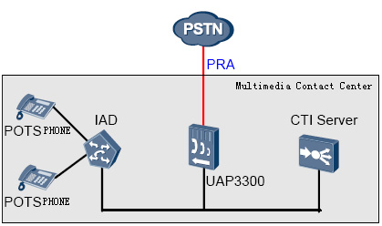

### 3. Network planning

|  |  |  |
| --- | --- | --- |
| **Equipment** | **Project** | **Reference value** |
| CTI Server | IP Address | 172.16.10.100/16 |
| Multimedia contact center number | 12345678 |
| CTI-Link | IP Address | 172.16.10.100/ 16 |
| Port number | 5600 |
| UAP3300 | IP Address | 192.168.3.40/16 |
| Module No. | 55 |
| Of UAP-the MRU Board slot number | 2 |
| Of UAP-DTUsBoard slot number | 3 |
| Of UAP-DTUsBoard to the corresponding number | 3 |
| Out fixed crown | 0 |
| IAD | IP Address | 172.16.10.30/16 |
| IAD The user number | 6000~6003 |
| PSTNSide | Start CRC Check | Start |
| Network location | network |

# 2 TopEngCall center platform installation and basic configuration

## 1. InstallationCTI Server

### 1. Configuration process

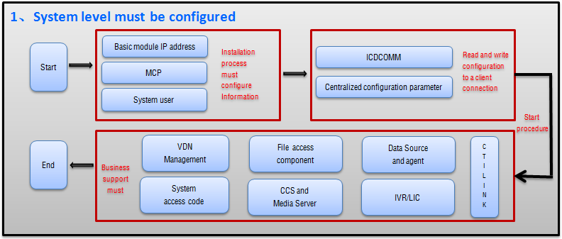

### 2. Installation steps in detail

An example to install the version ICDV300R005C15

Two CTI Version of the download address: <http://support.huawei.com>

3. Download Navigation:

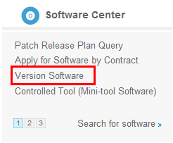

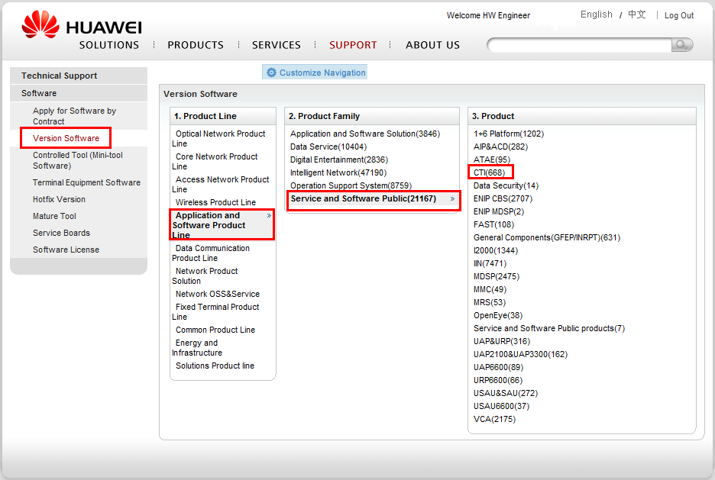

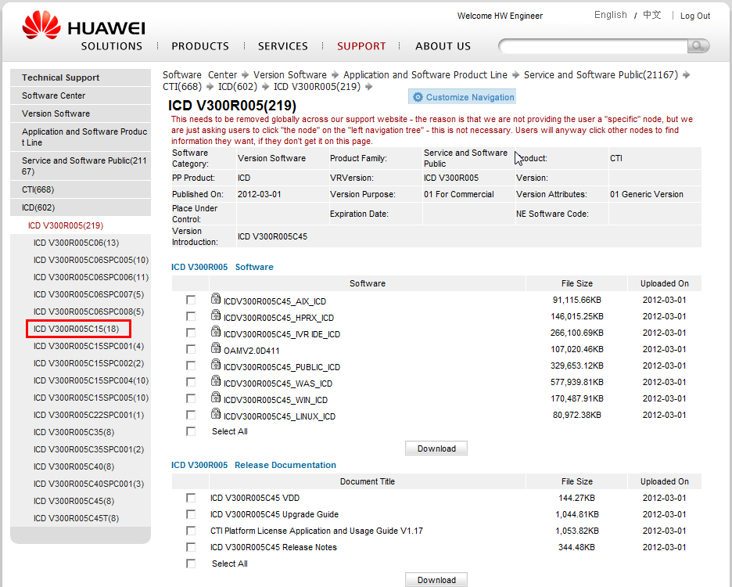

1. ClickSetup.exe and enter the installation process.

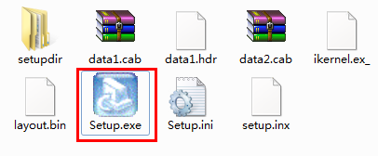

1. Select the installation directory and path.

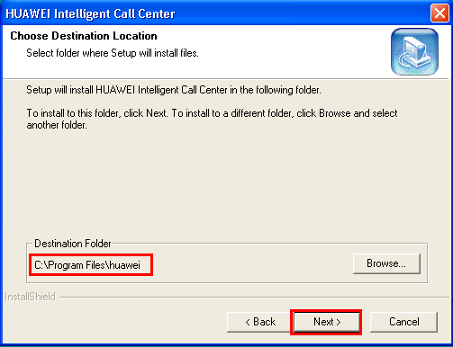

GeneralTopEngSmart call center default installation directory is C: \ Program Files \huawei

1. Select the type of installation

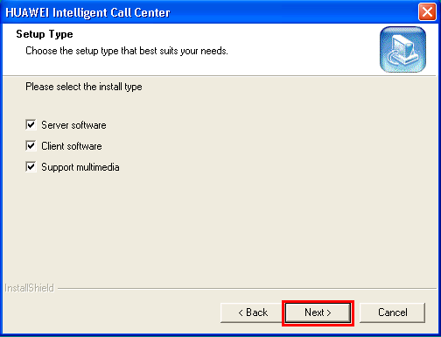

General CTI Server Installation includes Server software, Client software and Support multimedia This should be selected, if you need to open WECC Business, For agent desktop only client software needed to be installed.

1. Select the components you need to install

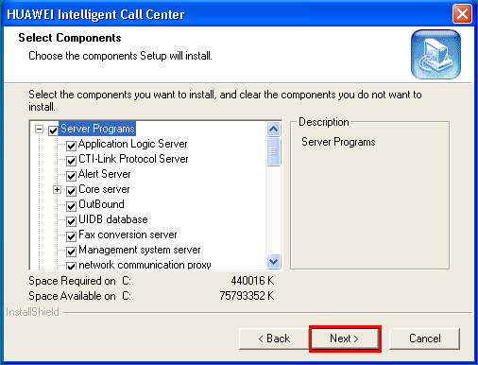

You can choose a specific component that needed to be installed.

1. Configuration of CCS IPAddress

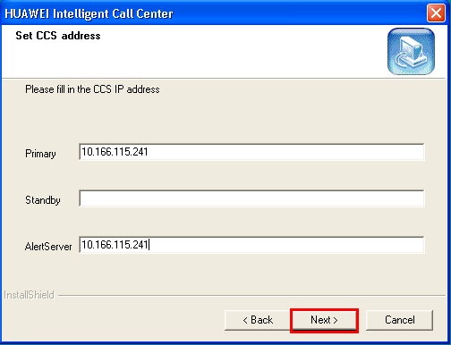

Configure standby detailed information in the CCS back up

1. Select the ACD type

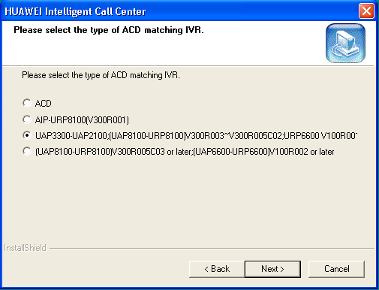

This is due to some versions of UAP. Details mentioned based in the UAP version choose the corresponding one.

1. Select the communication process

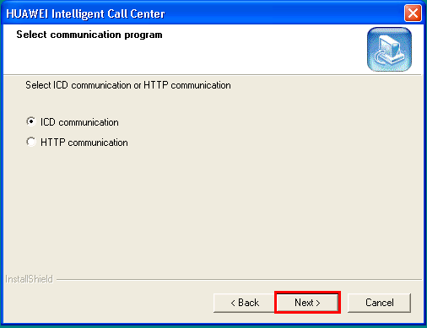

1. CTI-Link Configuration wizard (Can be configured later)

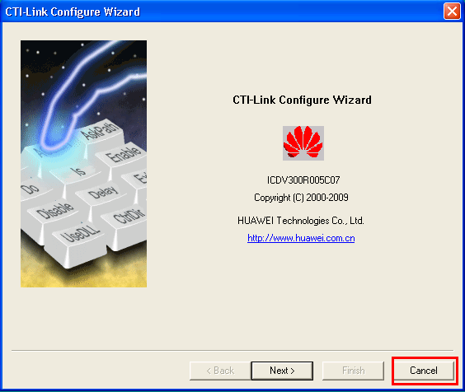

1. LoadLicense. IniFile

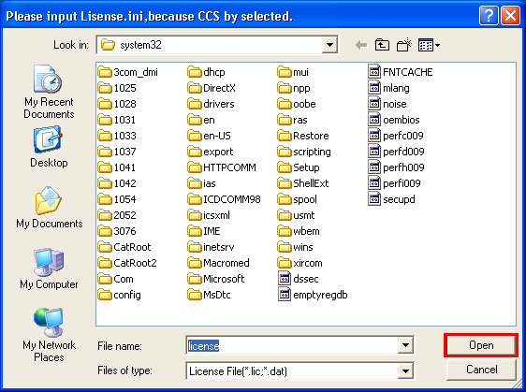

1. Start basic configuration

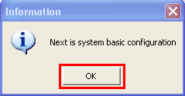

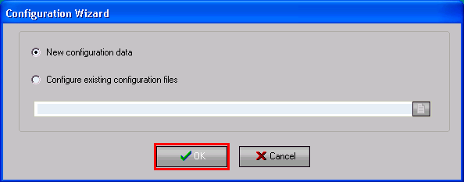

Note: If this is the first time installation, select New configuration data. The following parameters need to be configured.

If you need to inherit the original configuration file which exists, then configuration file path is C: \ Program Files \ huawei \ ICDCfgSvrDirectory\ICD3Cnfg.dat. Please select Start the configuration from an existing profile for this purpose.

1. The basic moduleIP

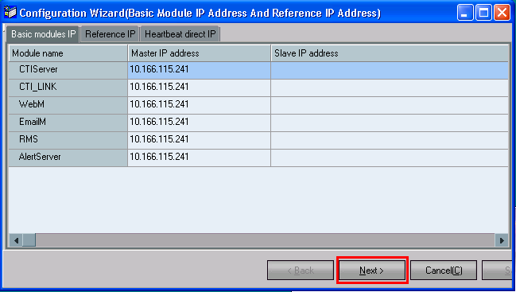

In this, Modules are mounted on the same machine, whose ip Address is 10.166.115.241. CTI Backup is not installed so backup ip’s are not configured. Reference IP Address configuration can configure multiple reference IP Address. Reference machine IP Address is mainly used to confirm the Master, the standby server is normal. The call center's core service program with standby operation, the timing between the main and backup server to send a handshake message, so to judge each other is functioning properly (once an exception occurs, the standby switching). The same time, continuous backup serverpingReference machine, ifpingAny reference address of the server with reference to the machine where the network is normal, heartbeat messages to determine their own standby. If no configuration referenceIPAddress, the standby server handshake fails, the primary server status is unchanged, the standby server switches mainly with servers, the system at the same time there are two main server.

1. MCP and WAS of IP Configuration

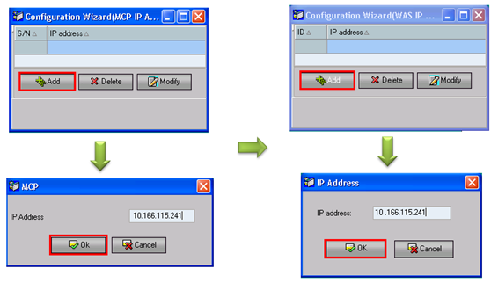

* MCP Management system application server, including file access components, database access components, alarm logs access to components, the client connecting to the proxy (MCP), MCP currently supports1000Connections.
* Note that the agent and client, centralized configuration Taiwan do not connect in the same MCP On.
* For Installation you need to configure at least a MCPAddress, or follow-up cannot log on centralized configuration Taiwan Record System data configuration, centralized configuration after installation to add other MCP Address.
* Must be configured WAS (Web Application Server, Web Application server)IP Address, the administrator before it is passedIESign InWebCentralized configuration to configuration.

1. Configure user groups and system users

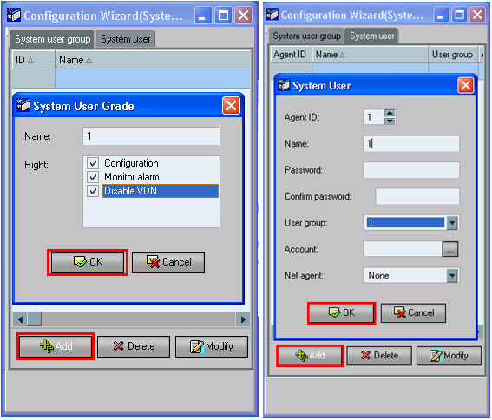

Note:

During Installation of CTI, Click Next to continue Installation. The CTI the LINK configured when the alarm units IP Address and focus on the configuration stage configuration Alert Server Inconsistent. Select Save to save the configuration.

Configure the system users, follow-up can be used to configure the system user login<Centralized configuration Taiwan> on the CTI Platform configuration of the system data.

1. Net check Configuration Taiwan

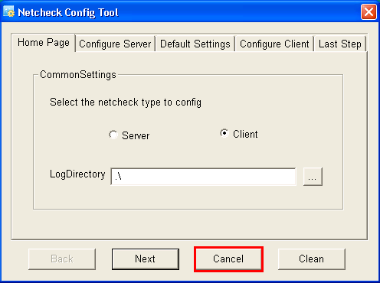

1. OutBoundConfiguration

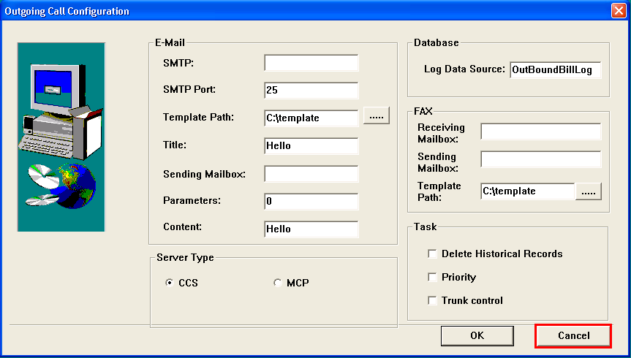

1. CCP Configuration

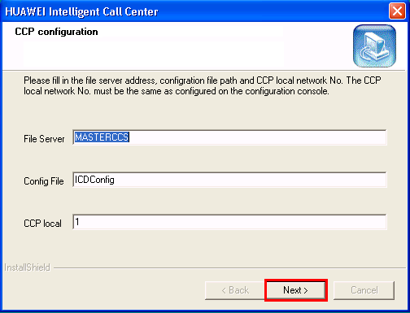

B194Here<Canceled>Is being blocked, but some version here can still click Cancel to need to pay attention!

1. NIRC Wizard Configuration

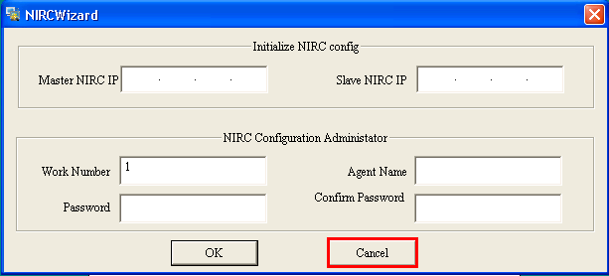

1. The end of the installation

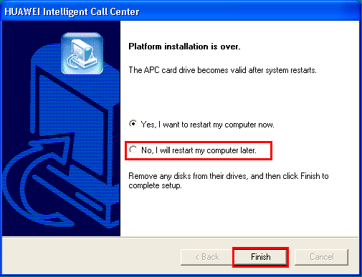

### 3, Summed up

Here, TopEng the call center has been installed completely. The following Data Configuration has to be considered.

* **The data configuration consists of two main parts, the first part of the configuration of the system level, the second part is VDN Configuration.**



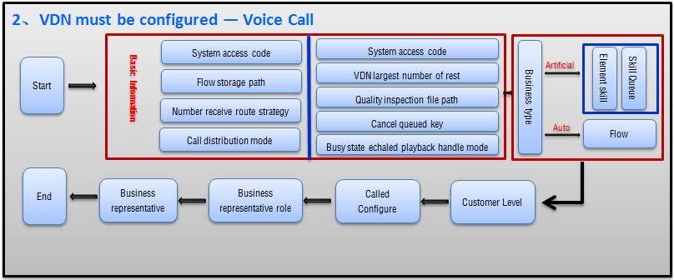

Can be found in System-level Configuration <Basic modeBlockIPAddress>,<MCP>,<Users of the system> these three Installations must be configured to process information. We have security configured.

The following "Client connections, read and write configuration necessary<ICDCOMM>,<System configuration sets of parameters>Configuration.

## Second, theSystemConfiguration

### ICDCOMMThe configuration

OpenICDConfigTwo ways

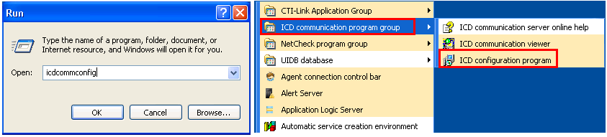

1) Start -->Run Enter icdcommconfig

2) Start -->All Programs -->Huawei Intelligent Call center-->ICD communication group --> ICD configuration program.

Configuration ICDCOMM

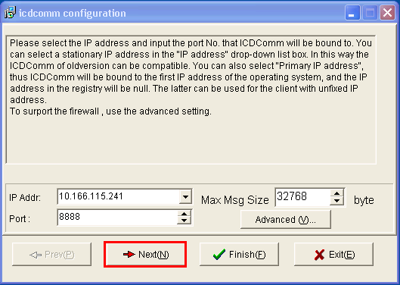

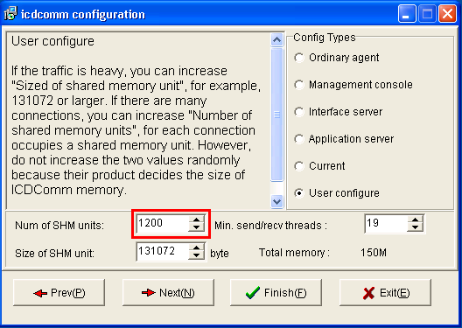

* The core server ICDCOMM IP Address should be the license binded ip address of the modules running in that machine.
* Default PORT is 8888. Recommend not to change.
* If MCP module is running in that machine and has more than 100 client connection. Then the shared cache memory units must be greater than the number of MCP client connection.

### The installation WAS

1. Installation Breeze MainAst (Maintenance assistant)

Directly run the installation package, complete the installation can use the default settings.

Installation Breeze MainAst Maintenance assistant is relatively simple, So no much illustration is required.

1. Run and Login maintenance assistant

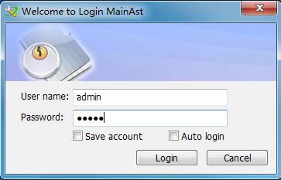

Account default password is: admin

1. Loaded call center platform for business maintenance service package

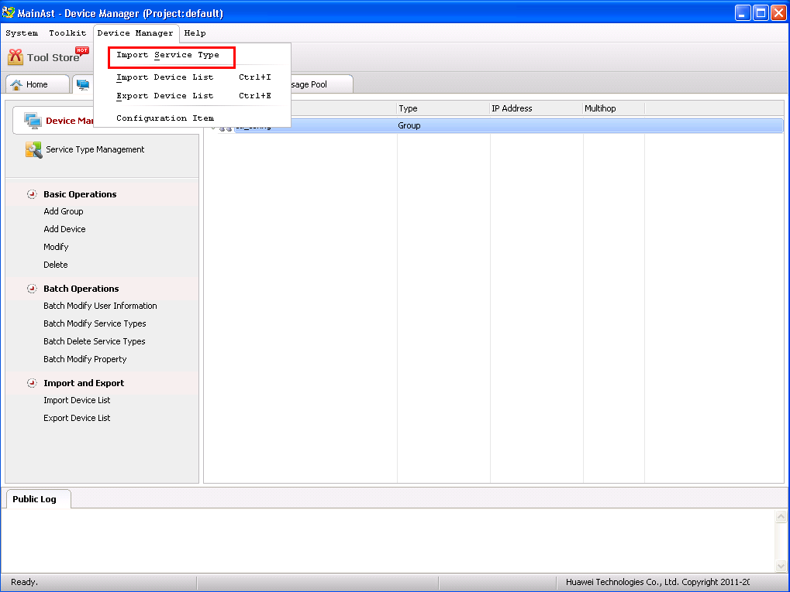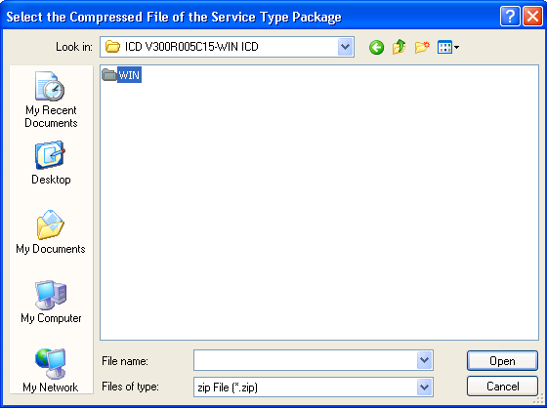

1. Add Device group and

In the "Device Manager" add the device group and device. You need to add the device according to the version of the platform which is supported by the service package as mentioned below.

CTI_WIN_FOR_ICDV300R002 Service Package is suitable for Windows CTI Customer service platformV300R002,V300R004 series version.

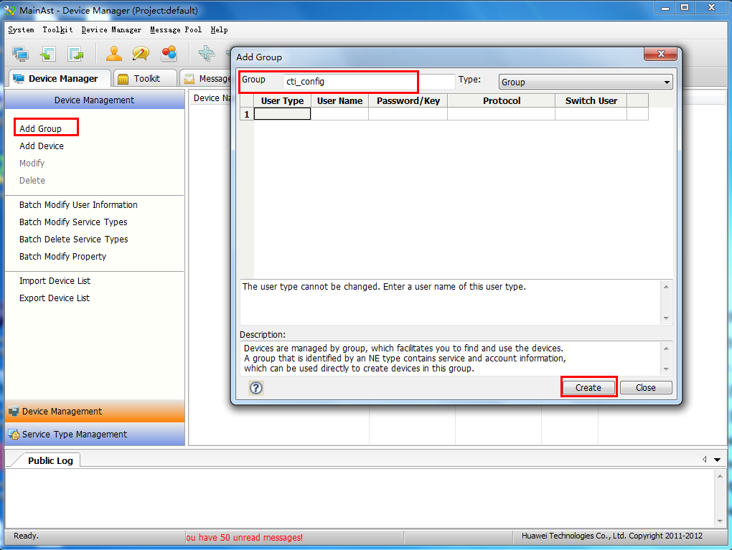

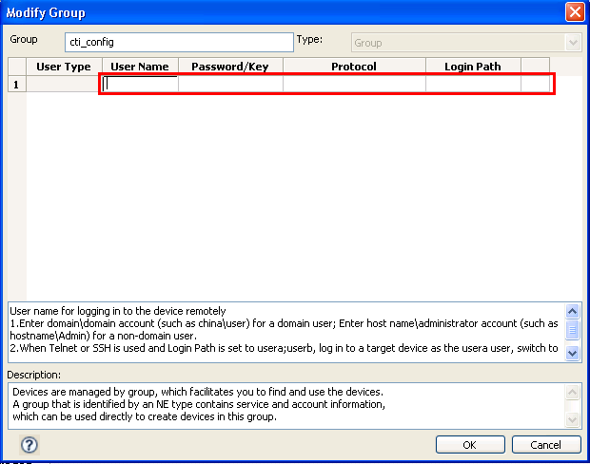

1. Maintenance Terminal

Select the "Toolkit>Maintanenece Terminal, the system displays the "Maintanence Terminal" tab.

This tab you can see the added device, with the services available.

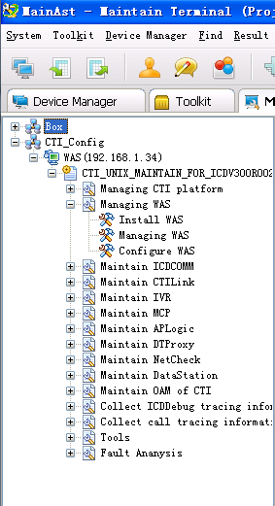

1. Installation WAS

Click Managing Was -->Install WAS link under the device adeded for installing the WAS. Select the WAS Platform installation package directory where; (... \ Public \ was \ packages)

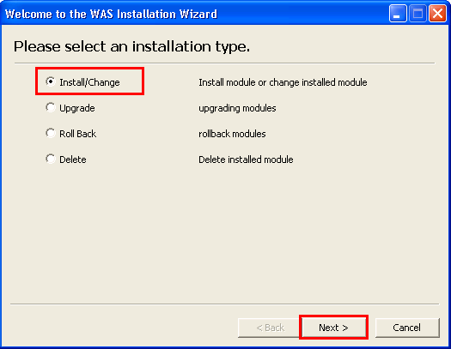

Click "Next"

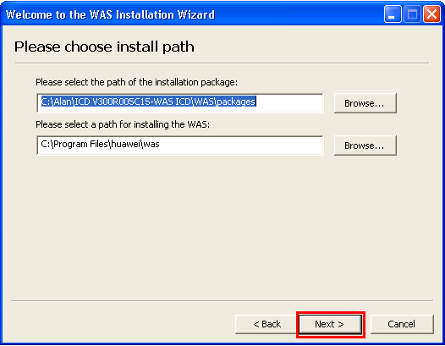

Click "Next"

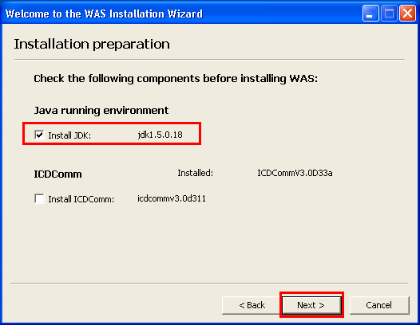

Click "Next"

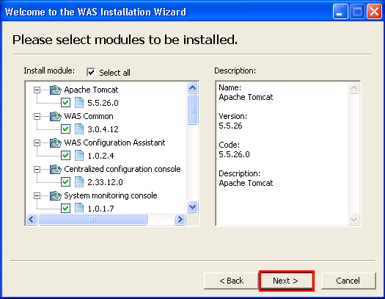

Click "Next" again, click on "install"

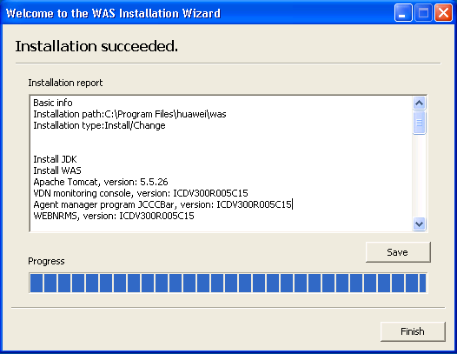

1. Start WAS

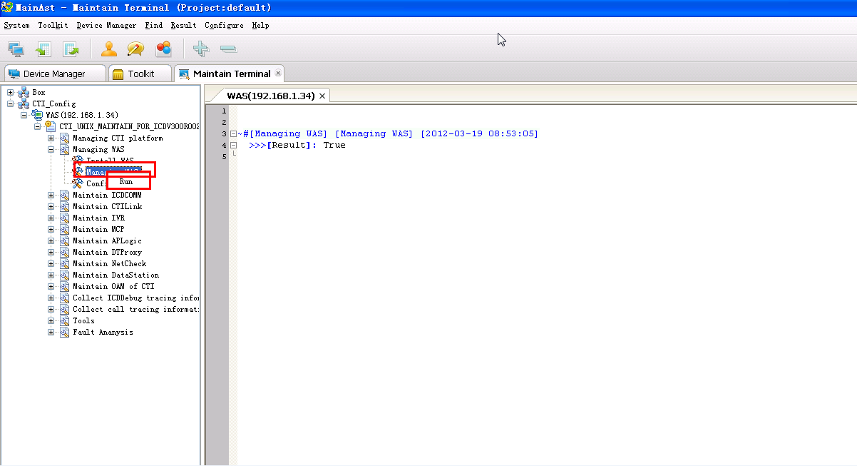

### Configuration WAS

Click --> Configure WAS to open the WAS assistant login page, Default username/password is admin/admin

The login address is: <http://127.0.0.1:8080/assistant/>

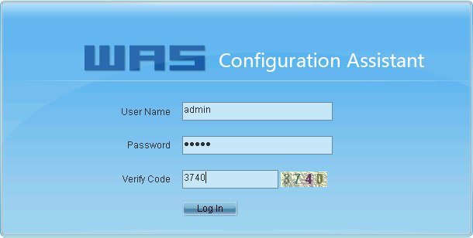

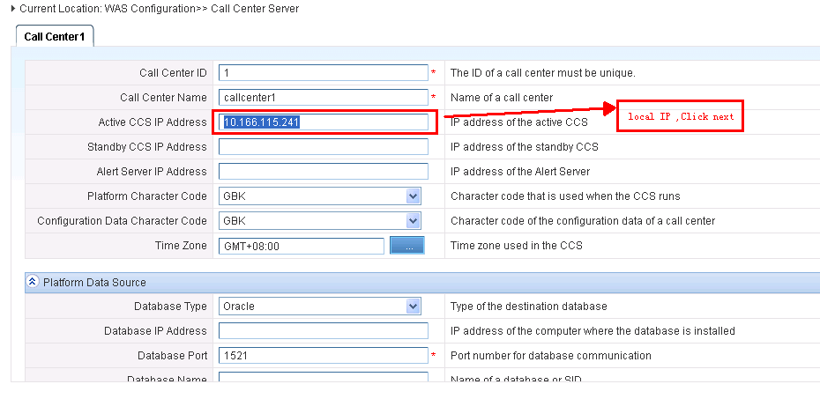

Enter the IP Address of WAS machine where it is running. If multiple NICs are available in that machine, then you have to provide the IP Address of the NIC which you are going to use it for communication..

### The use of WAS

Use http://WASServerIP: 8080Enter WAS Page.

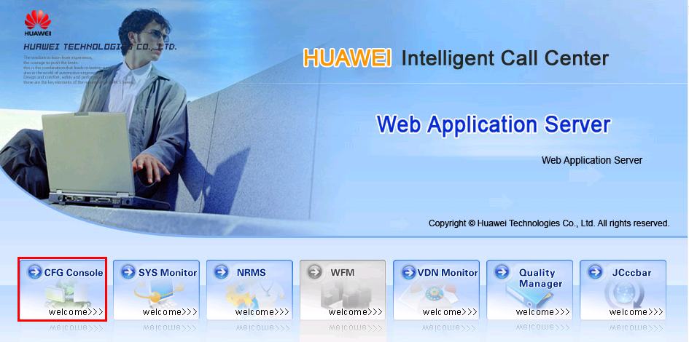

Enter Web Configuration using system admin 1 or go in offline mode.

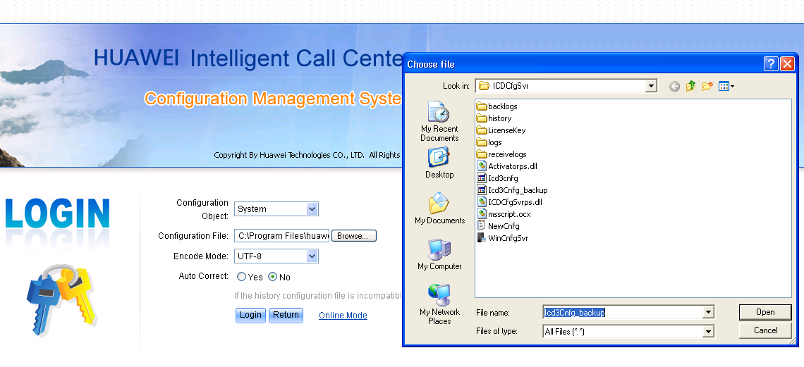

Click to login, you can do the configuration,and Check Configuration in the main module information

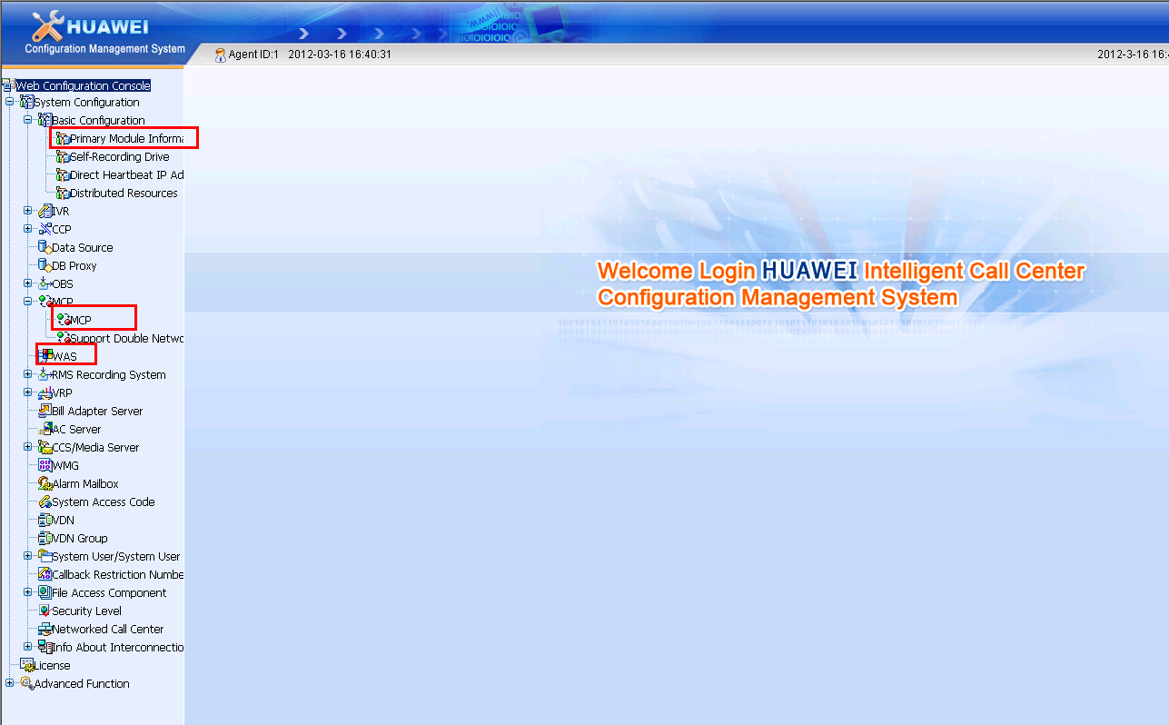

After submission, logout Web Configuration, reboot the machine.

### Configure the call center

1. Open monitoring proxy server MDS

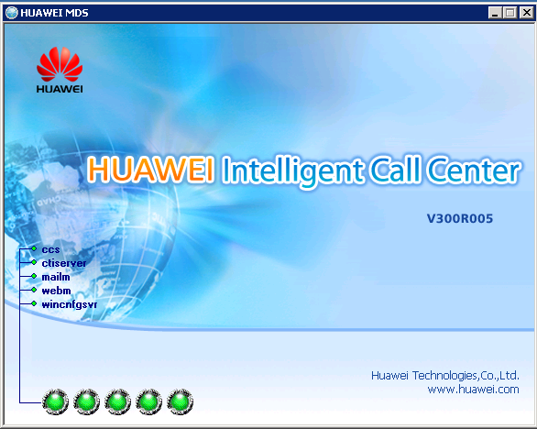

* The Master server up status lights in green, standby status lights in blue, yellow means starting up, red is for exception and server is not started.
* Use ALT +CTRL +SHIFT+ D, Can switch MDS Interface, from MDS Service interface, you can see the current state all the server .

1. Open Management System Application Server MAS(The actual open MCP)

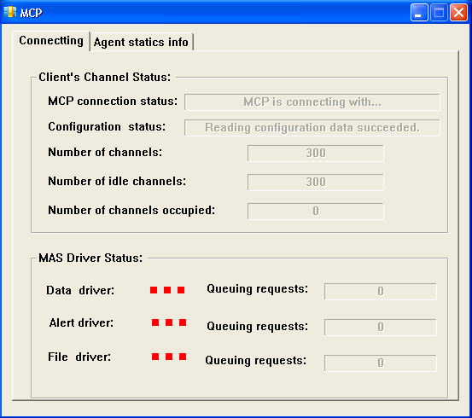

1. Enter Web Configuration

Reference system System-level With Center Configuration items

Can be found there are the following are not configuration

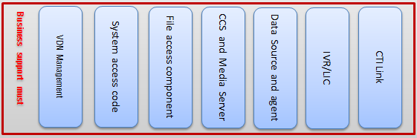

First start WAS (Can be started directly.. \ Huawei\ Was \bin \ startup.bat)

Then use URL http://WASServerIP: 8080 to enter WASPage.

Login with system admin (Login ID 1)

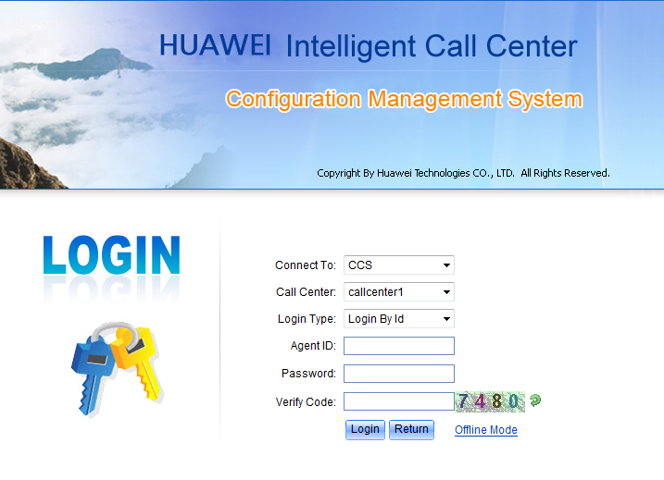

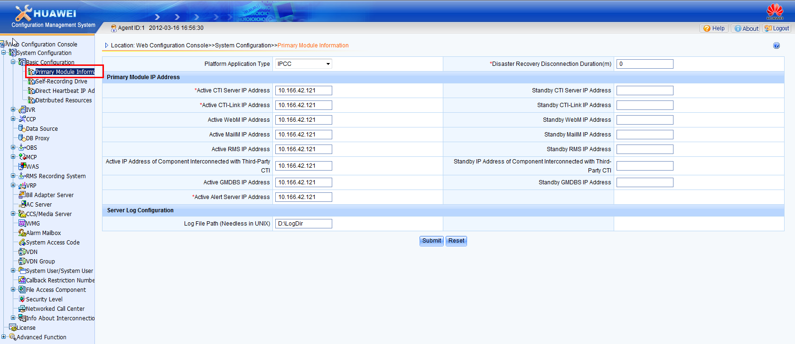

You can now use WAS to configure our call center system.

Basic configuration

* Provide master and standby IP Adresses of the servers. If standby is not available you can leave it blank.,
* Reference machine IP Address configuration: Request5AIPAbove, and the corresponding machine24Hours without interruption.
* IP Gateway: If there is no WECC This is not required.
* The path to the server log: The log server path where logs will be written. For Linux machine this is not required.

1. Configuration Cti-Link

CTI-Link acts as a channel for UAP to connect to CTI.

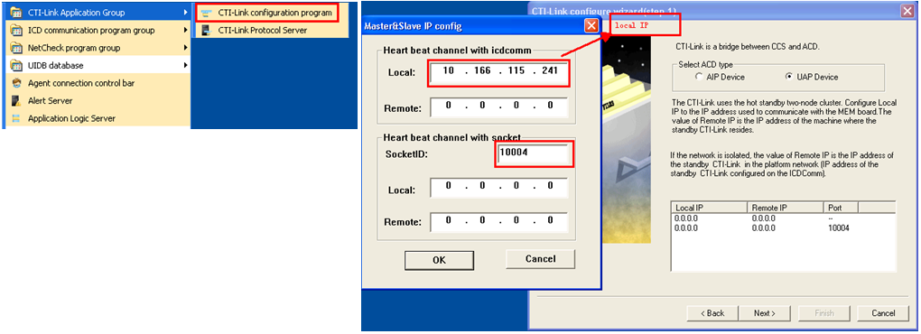

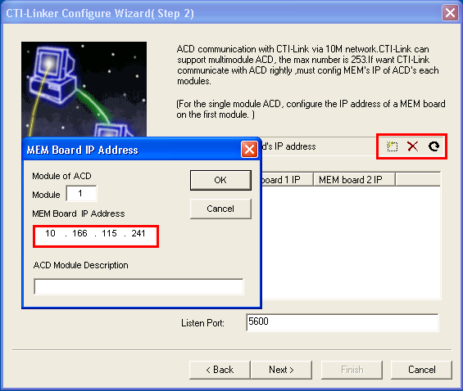

Enter your IPAddress.as per the Network Diagram

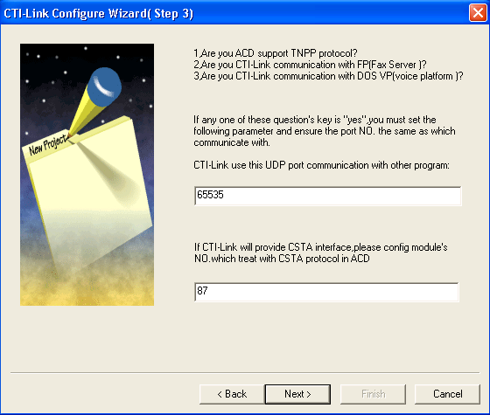

Click Next, by default to complete.

1. Start CTI-Link Protocol server

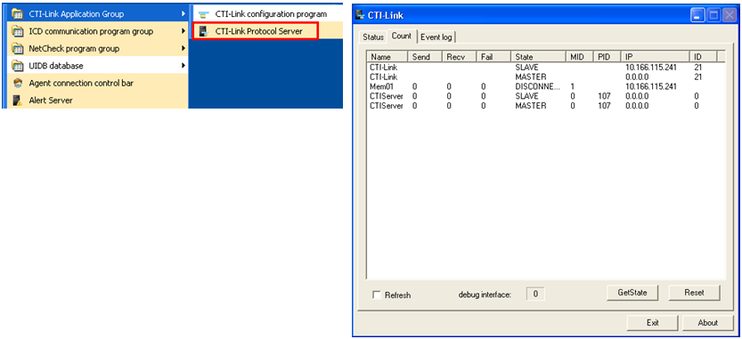

Start the CTI-Link protocol Server

1. Configuration IVR

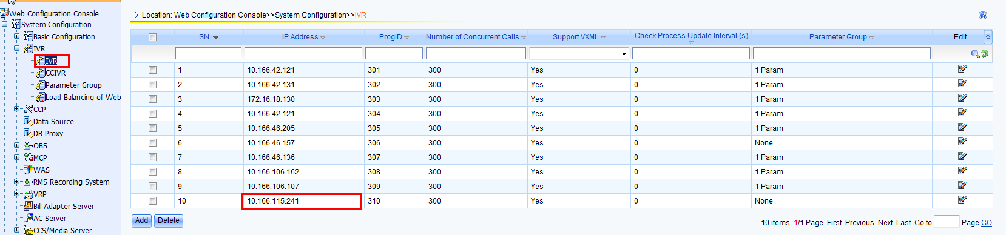

* IPAddress: IVR Server IPAddress, if the IVR has been a reference to the IP then it cannot be modified
* While the number of calls handled: IVR Range of the number of calls handled 1 to 2000. The default value is 300.The value of the memory resources, the greater the value, need more memory.
* Whether to support the Voice XML Characteristics: whether it can be load VXML files.
* The detection process the update interval: range 0 to 1200, 0 then ivr will not be loaded automatically.

1. Data source and data source agent

* Platform data source to the system, VDN Business data source to VDN, Third-party data sources to the business use of platform data source and only one VDN data source can be configured per VDN.
* A data source can be loaded in more than one database agent, a database proxy can load multiple data sources.
* DTPROXY and APLOGIC are the two categories of database agent. The way the connection made to the database is different for APLOGIC and DTPROXY.

1. CCS /Media Server

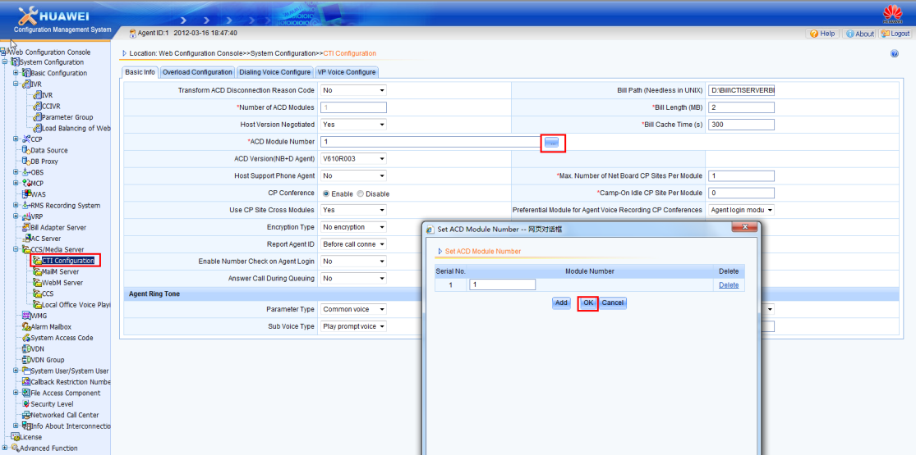

* UAP module number must be configured correctly, otherwise it will lead to some misbehavior of the system.

1. File Access Components

Slightly

1. System access code

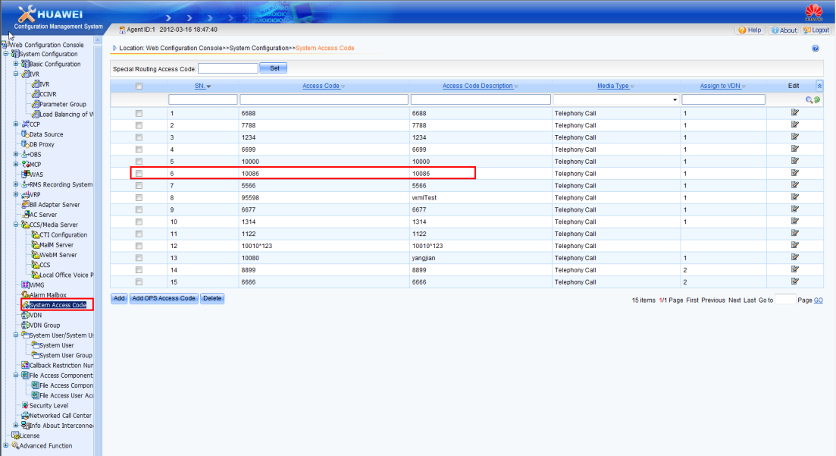

Added were added to 1234 and 6688 two access codes, 1234 Used as a IVR Access code,6688 Used as artificial voice access code.

* The access code cannot be repeated, including special routing access code and the network access code
* Special routing access code need to be set only when WECC click to call is involved.

1. VDN Management

**Editing VDN Basic information

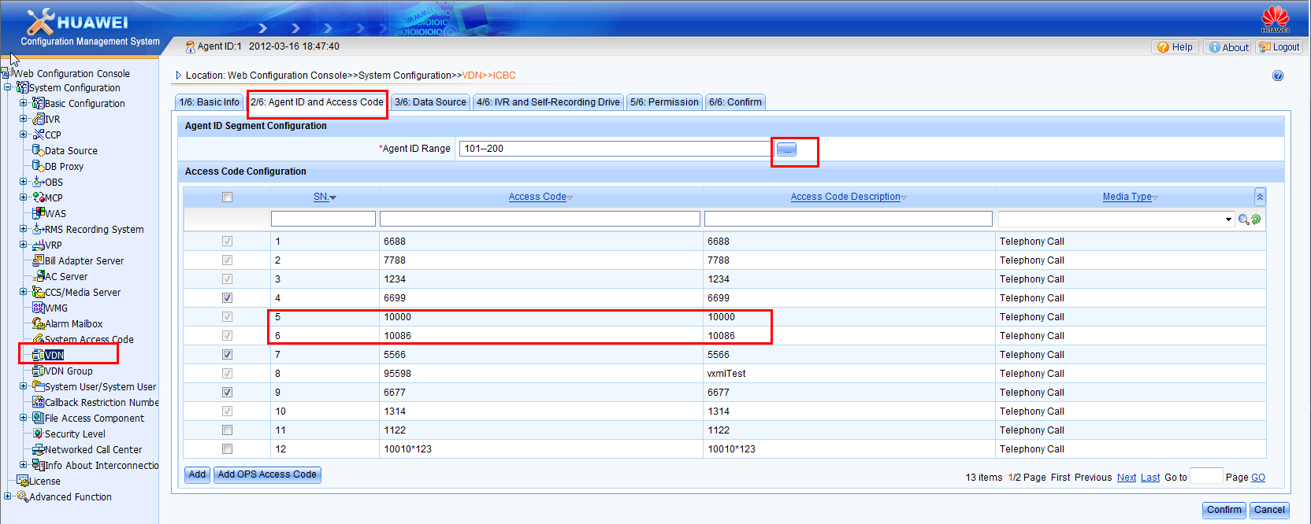

**Select the agent number range and access code

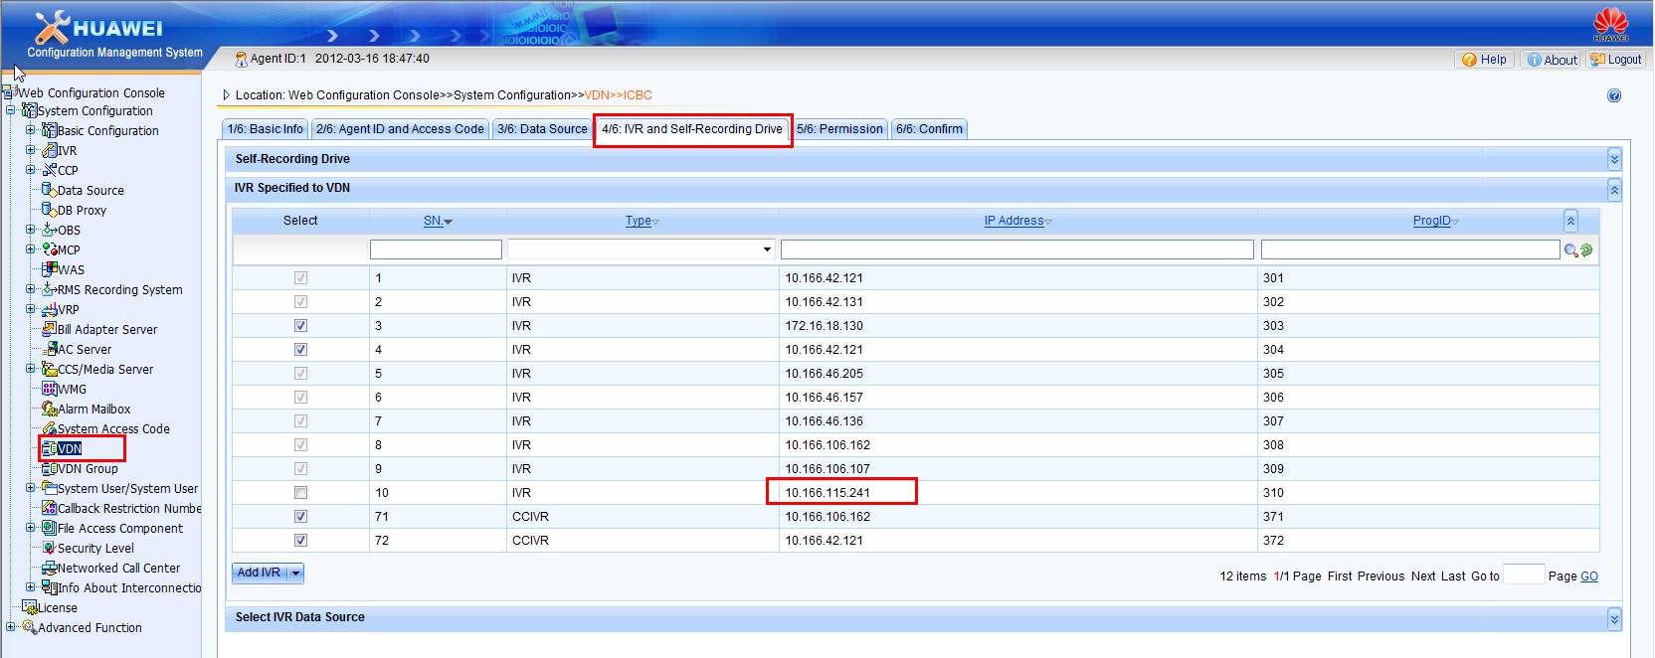

**Select IVR specified to the VDN.

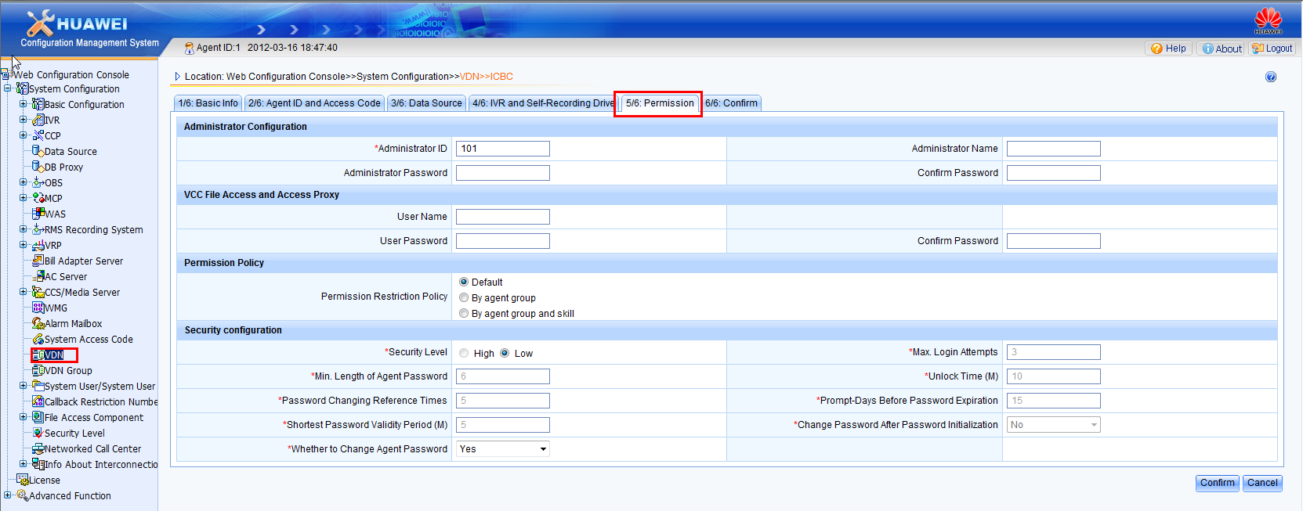

**Configuring the VDN administrator

### Likely to encounter problems and its solutions

## ThreeVDNConfiguration

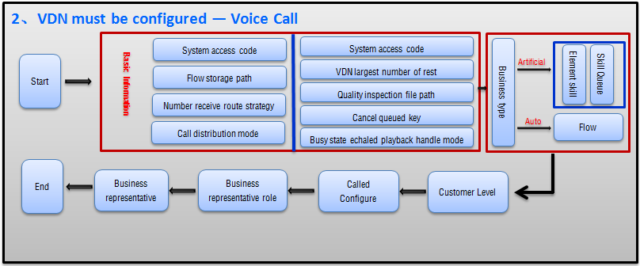

Of italics configuration, such as special needs generally use the default option

### Basic information

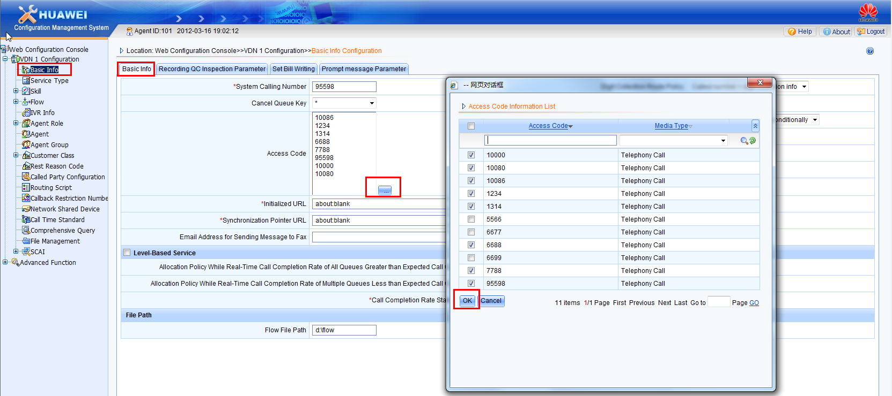

An example: InVDN110086 and 6688 are the two access codes.

IVR flow file storage path default is c:\ drive, Can be changed as needed.

Note: This path is only for GSL flies not for VXML files.

### ConfigurationType of business

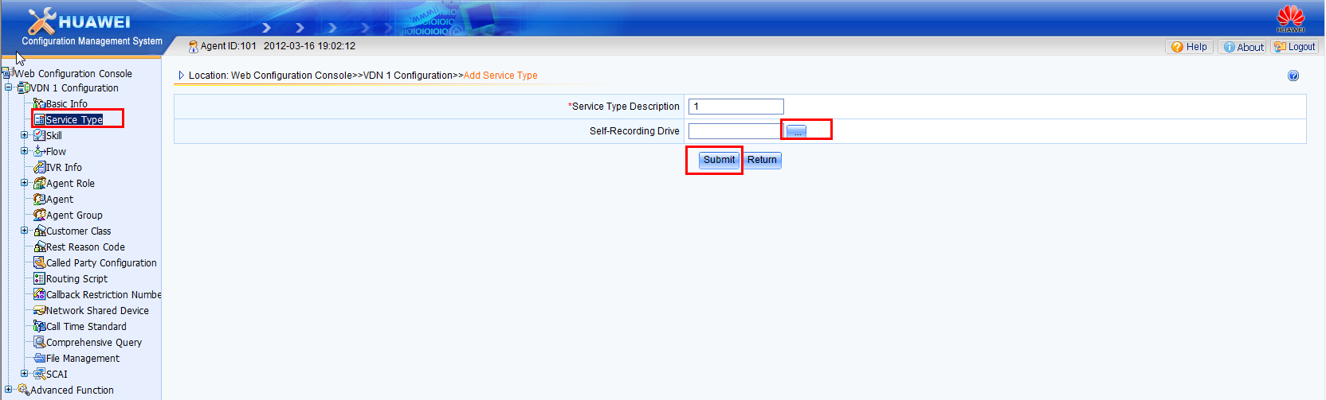

Step 1: In VDN Management of the directory tree, select the Service Type.

Step 2: Click "Add" to add the service type.

Enter the various type of service like voice, chat and so on.

Step 3: Submit configuration data.

### Configuration skills

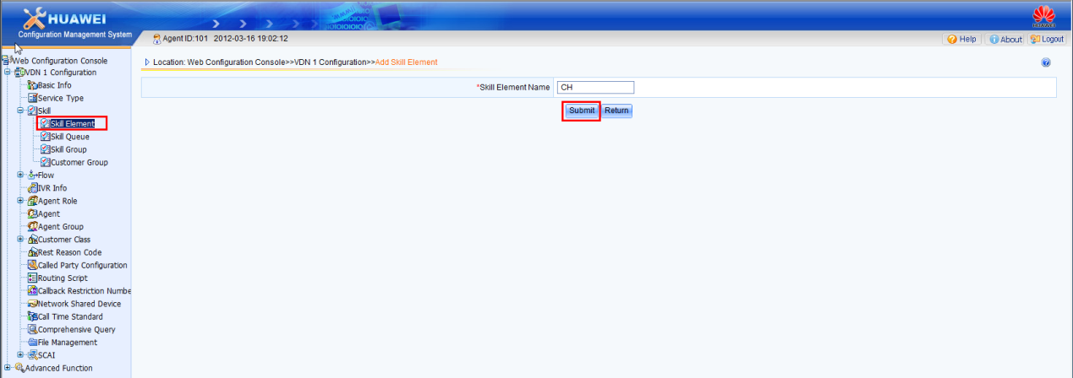

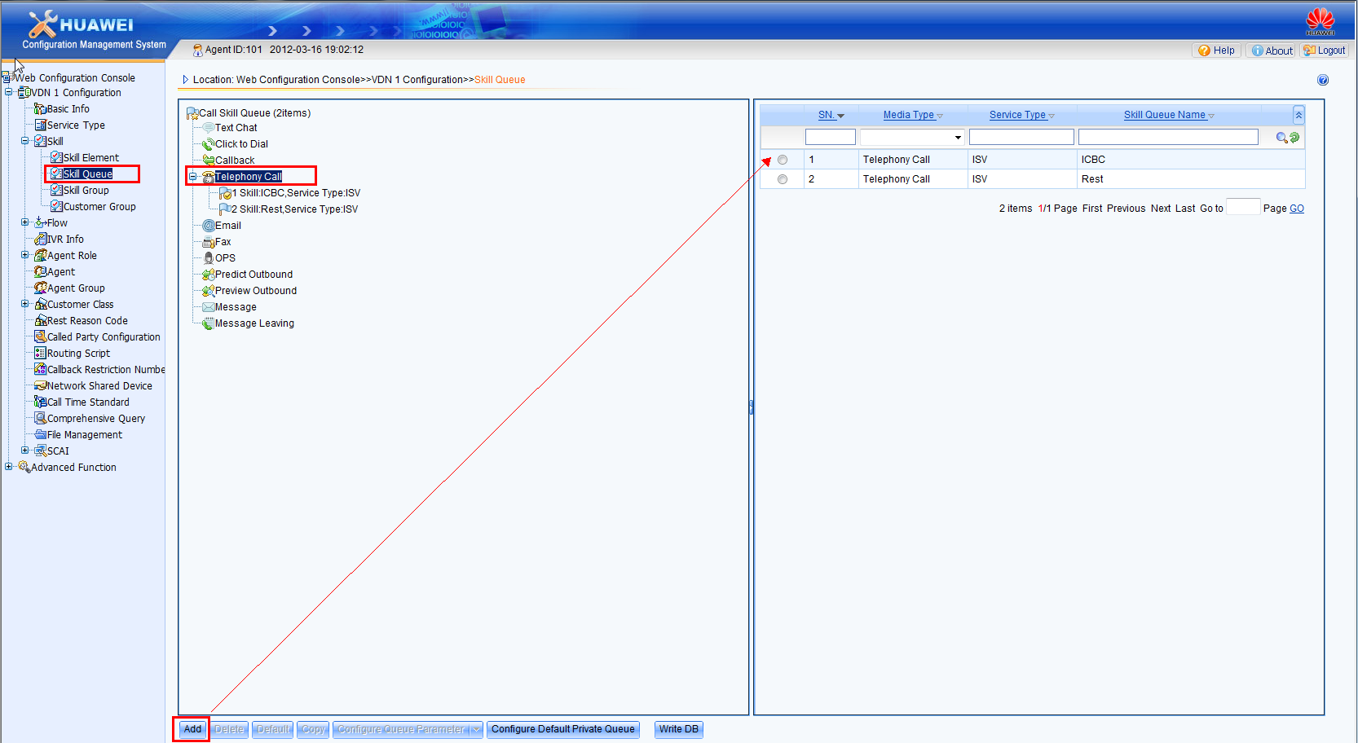

### Configuration process

Step1 In VDN Management of the directory tree, select the "Flow" node.

Step2: Click "Add" to add the flow.

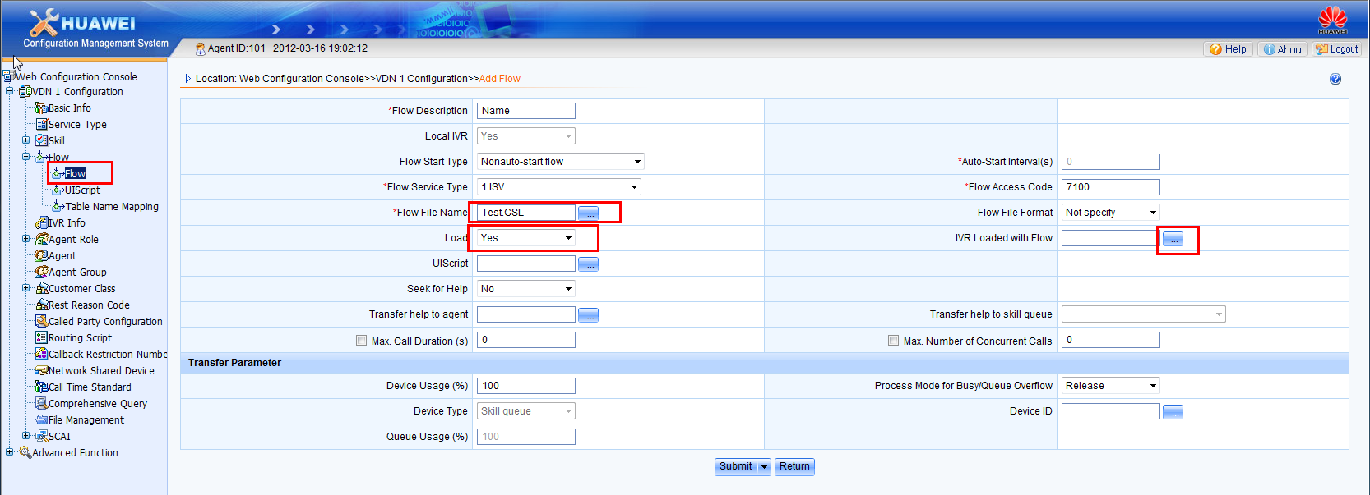

Step 3: Submit configuration data.

----End

### Called number

Step 1: In VDN Management directory tree, select the "Call Party Configuration”.

Step 2: Click "add" to add a access code mapping to corresponding device(Skill or IVR)

### Representative role

### Sales Representative

# IVR Configuration process

## First, theSystem Configuration

Step1. Login in to WAS configuration console.

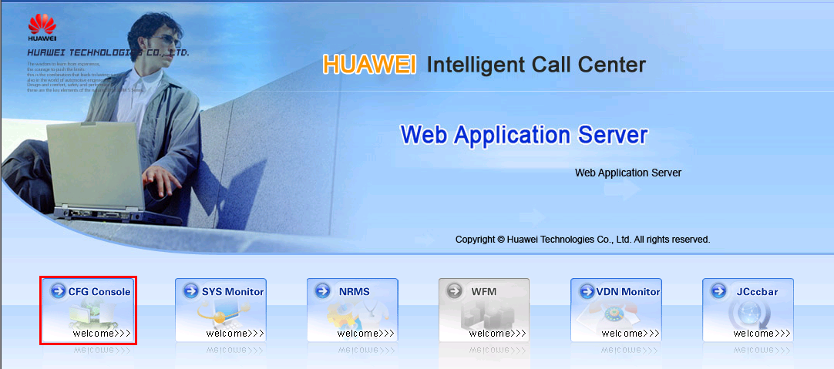

Step2. Once you have logged in Select “System Configuration”--> IVR--> IVR.

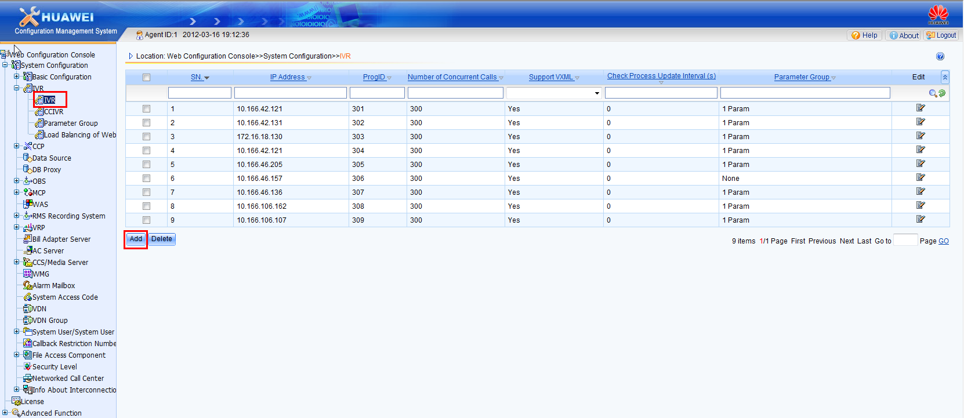

Click "ADD" Button, add an IVR server.

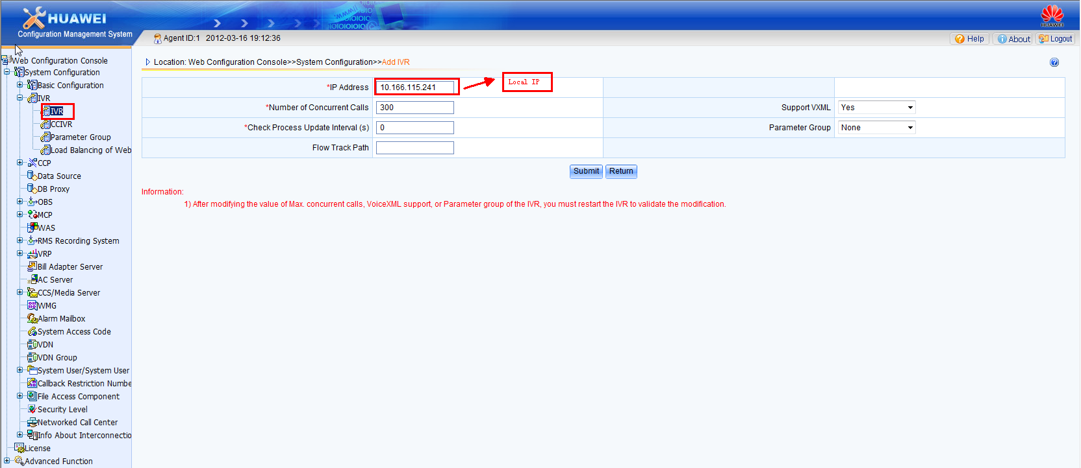

Step3. After adding the IVR server , Click "System Configuration🡪VDN", Goto Agent ID and Acess code tab. In Access code configuration click Add button and enter the access code for IVR and select the media type as Telephony call.

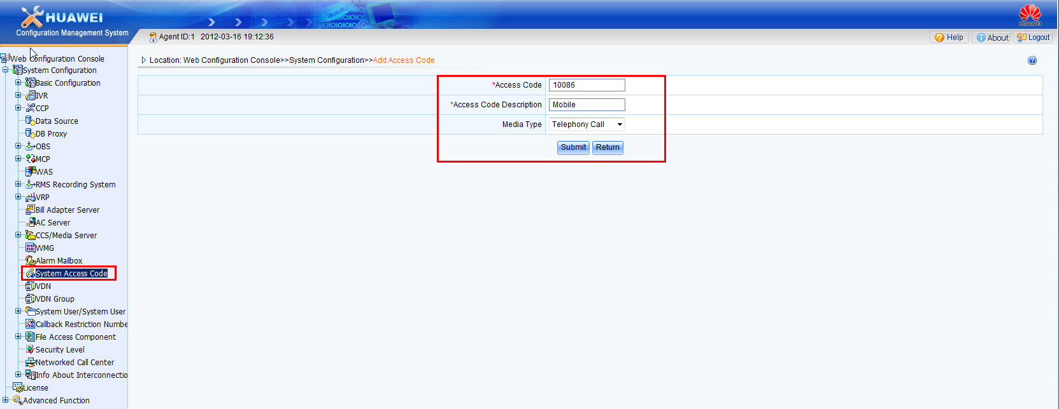

Let the Access code configured is 10086 anf Access code descriptions can be filled as: China Mobile, Media type: Telephony call

1. Enter"4/6: IVR Self-recording drive" TAB Page, select the "Self-recording drive letter" section , Then click "add " Button and add a self-recording drive for the IVR.

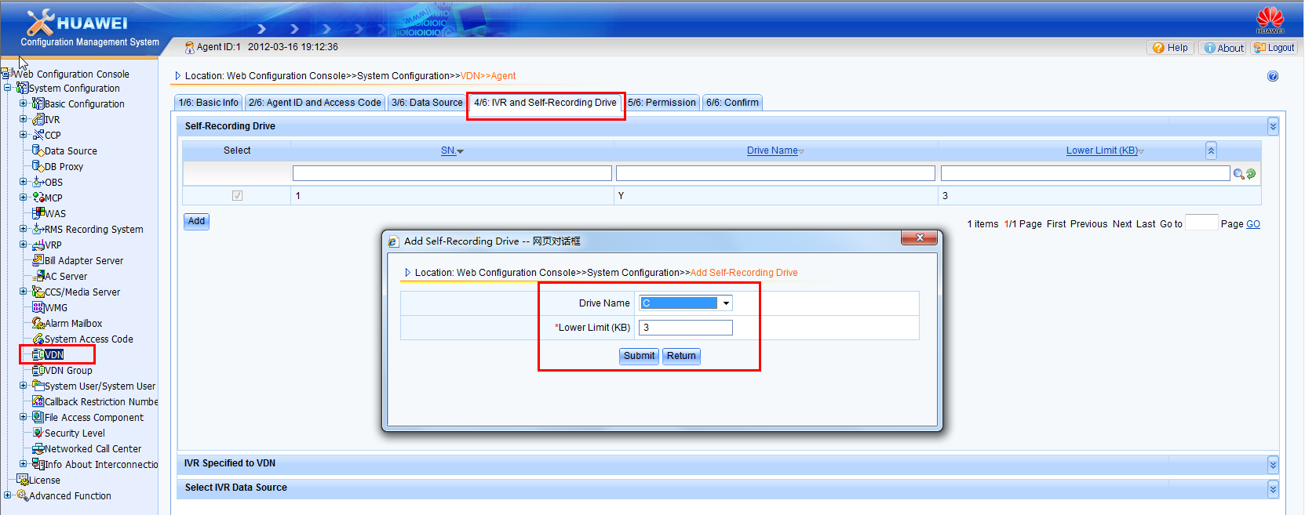

After adding select the section “IVR Specified to VDN” , Select the previously added IVR.

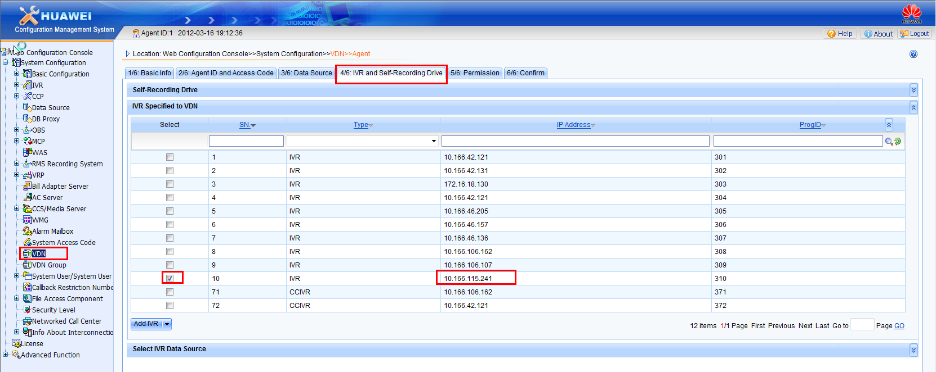

After completing all the configuration click confirm and submit.

Step4. After completion of the above addition, logout system administrator user, and login with VDN administrator (101 User login) in WAS Configuration console

Enter the "web Configuration Console🡪VDN1Configuration🡪Basic information"

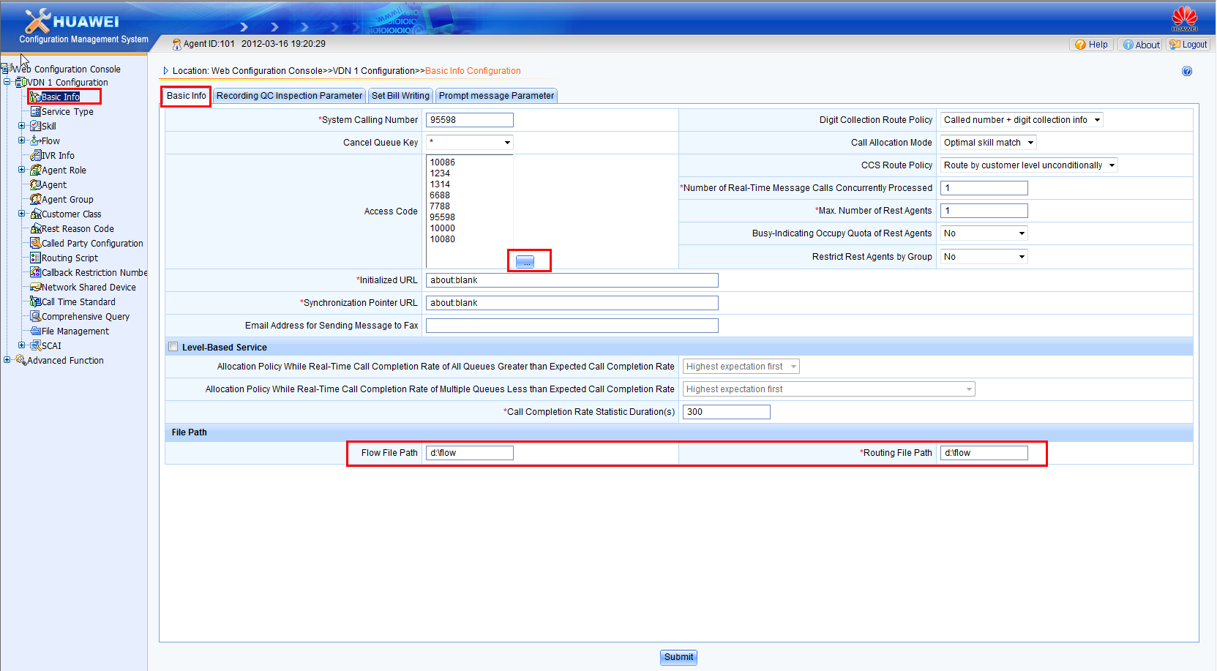

In "Basic information" TAB Corresponding select the access code 10086 and check the Flow file path and Routing File path.

Step5. Enter "web Configuration console🡪VDN1 Configuration🡪Flow🡪Flow", Then click "add" Button

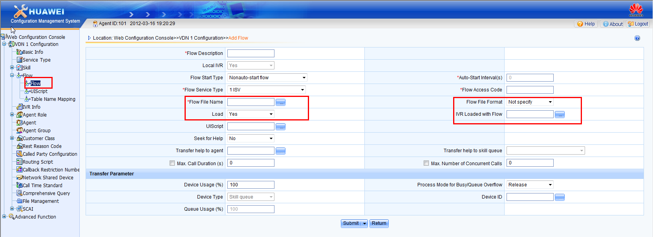

Fill in the appropriate "Flow description"," Flow file name", "Flow access code", "Load" and select the IVR servers where the flow needed to be loaded. After filling the required information click submit.

Step6. Enter "web Configuration Console🡪VDN1 Configuration🡪Call Party configuration", then click "add" Button.

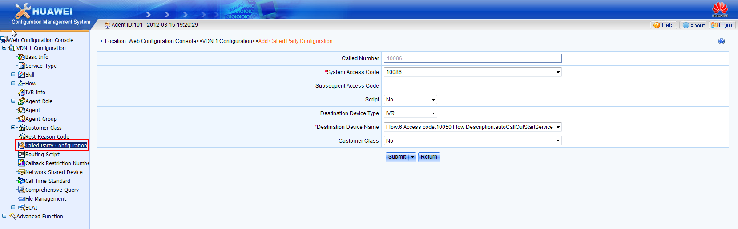

Select the appropriate "System access code", Select the target device type "IVR" and then select the appropriate "The destination device Call" Upon completion of the above, click on "Submit" Button..

## Second, theOperation and monitoringIVRProcess

1. IVR Modify the attributes

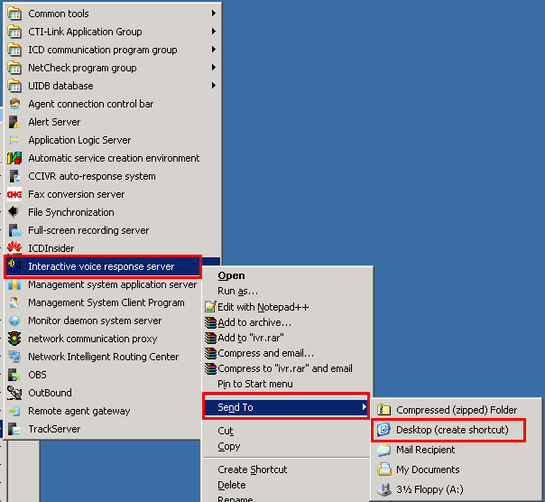

Create a short cut for the IVR server in the desktop.

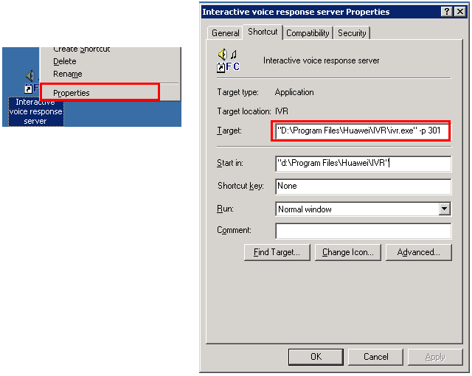

Right click -->Shortcut tab, In target field add –p{Program iD}.

For example:

["The original path"-p 301],

C: \ Program Files \ huawei \ IVR \ ivr.exe"-p 301

Start IVR Service.

1. Direct Double-click on the shortcut will start the IVR server with program ID.



1. To start IVR server by MDS,

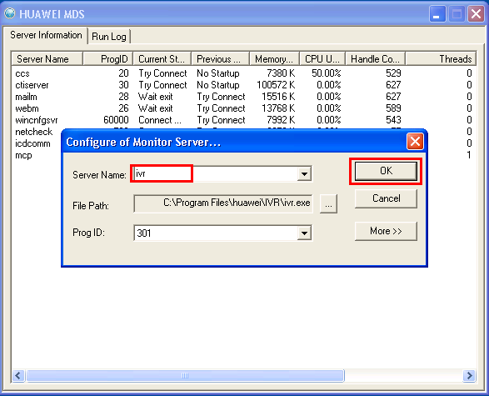

Right click 🡪Add server🡪Select ivr 🡪Ok

1. Loading process and Run

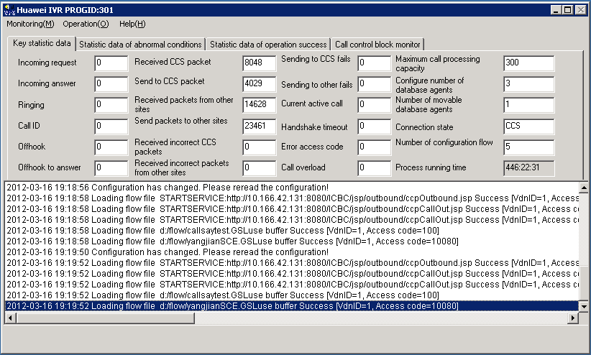

Select"Monitor🡪Display call monitoring window"

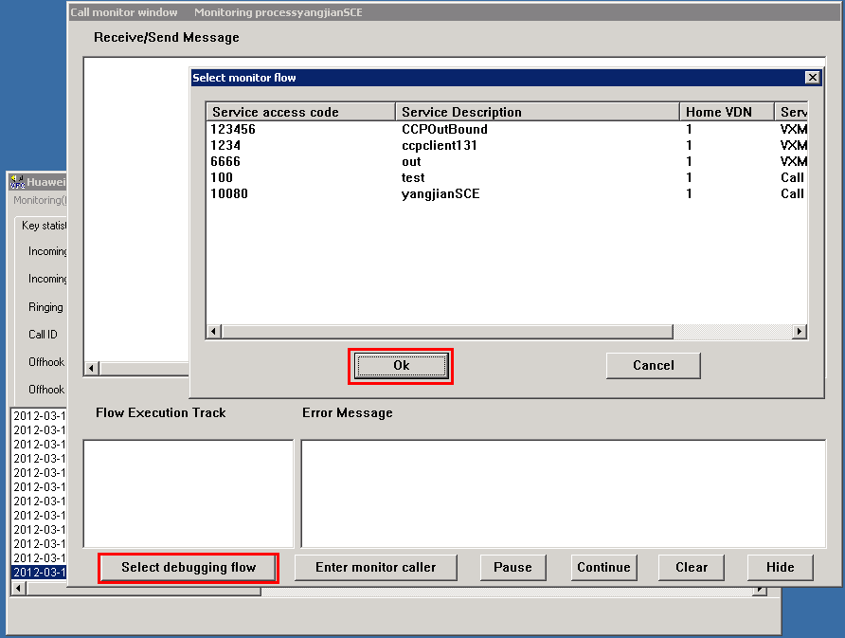

Select the debugging flow needed to be monitored and click on "Ok" Button

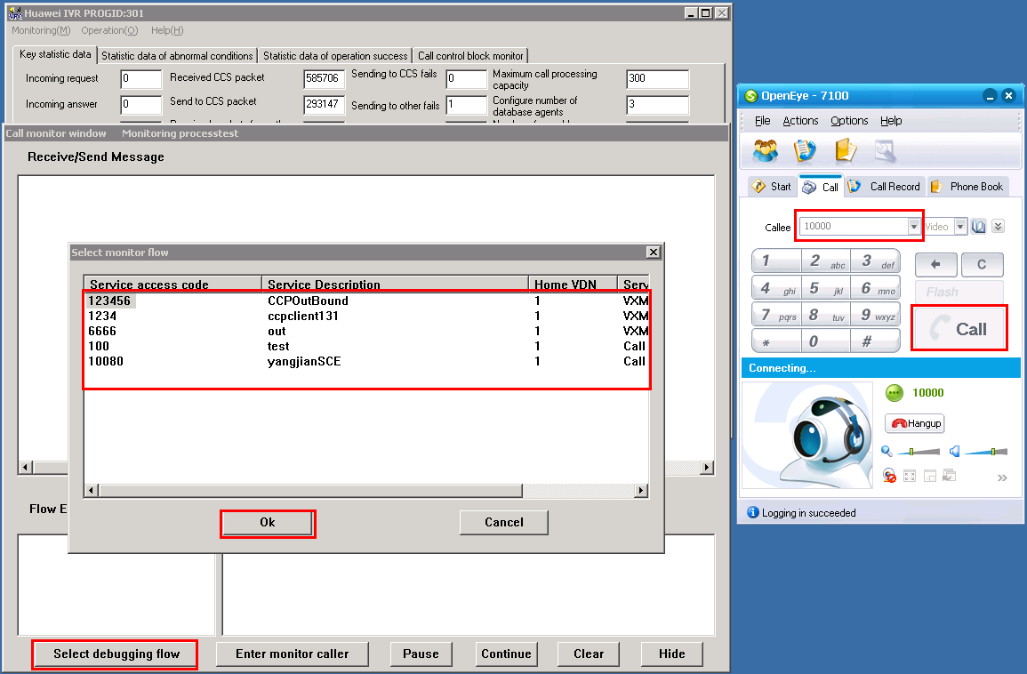

Use openeye to call the IVR service flow by entering the access code configured in the call party configuration, When the call is connected, In the call monitoring winow you will be able to see the current flows send and receicve messages.

# WINUAP Installation and configuration guidance

## First, theInstallation and configuration process

### Double-click on the installation package:



### Welcome screen

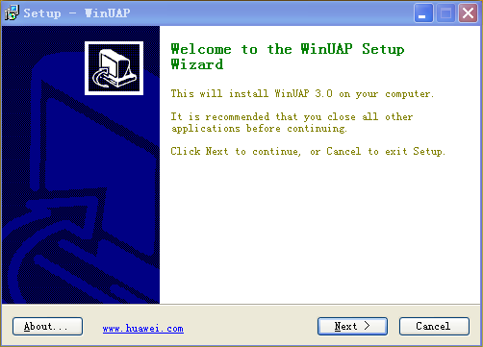

Continue the installation click "Next" , to exit the installation Click "Cancel"

Huawei, click the "About" button for more information click on the "www.huawei.com

### Personal Information

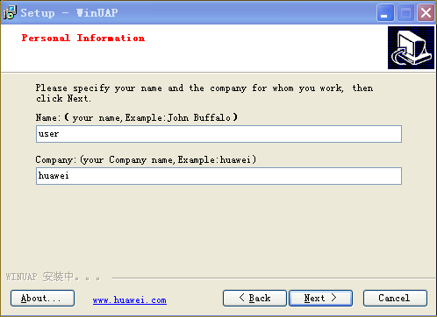

Please enter your user name and your company name, continue with the installation click "Next" To exit the installation Click "Cancel", Go back and click the "Back"

Huawei, click the "About" button for more information click on the "www.huawei.com

### System configuration information

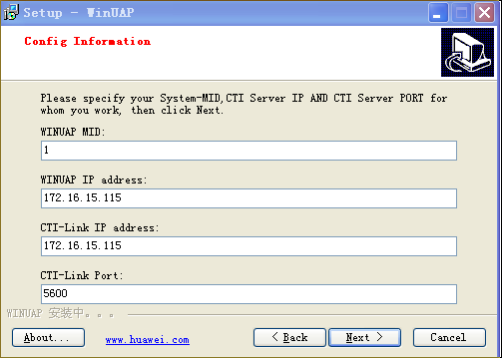

Please specify the system module and CTI Server address, port number.

Continue the installation click "Next" To exit the installation click "Cancel",

Go back and click the "Back".

Huawei, click the "About" button for more information click on the "www.huawei.com

WINUAPMID: The system Module Number

Range: <254>

Role: Win UAP System module number can be any value within the range specified as

WINUAP IP address: System IP

Set-based machine's IP address can

The CTI-Link IP address: IP address of the CTI- Link running server.

The CTI-Link PORT: This should match with CTI-Link configuration.

Effect:Must specify the correct CTIServer address and port number, Otherwise in Win UAP Some functions will not work properly, the concrete can be determined according to the CTI installation machine. The port number using the system default can

For example: CTI installed in the address10.166.16.200 Machine, here to specify the IP 10.166.16.200 and default port 5600.

5,Configure user information

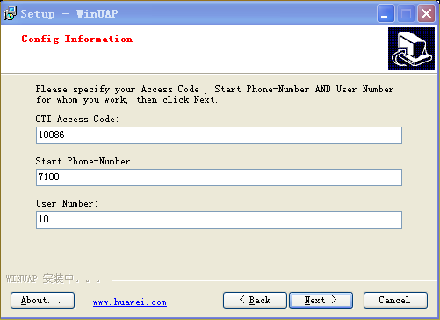

Please specify the user access code and starting phone number and the number of users, continue with the installation click "Next" to exit the installation "Cancel" to return to the previous step, click the "Back".

Huawei, click the "About" button for more information click on the "www.huawei.com

Access Code: user access code

Range: 1-16 figures, such as: 10086

Role: IVR (Interactive Voice Response), call center Function using the

Start Phone-Number: starting user phone number

Range of values:4 To 31 digits, such as: 7100

Role: openeye, log on to Win UAP with this phone number , the user starting with,

User Number: the number of users

Range: 1 to 1024 integer, such as:10

: Specifies the number of subscriber number

Example: to specify the "Start Phone-Number" for 7100, the "User Number"10, the phone numbers will be: 7100,7101,7102......7109

### Select the installation path

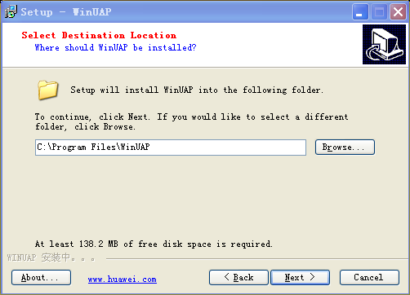

Please select the installation path. Continue the installation by clicking "Next", "Cancel" to exit the installation, go back and click the "Back" Huawei, click the "About" button for more information click on the "www.huawei.com

The default installation path is C: \ Program Files \ Win UAP Change the installation path click "Browse" to browse button to select Win UAP

### Select the Start Menu folder

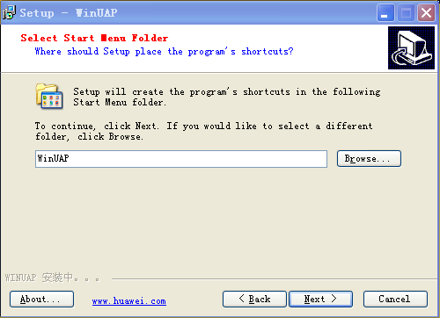

Please Select Start Menu folder Continue the installation by clicking click "Next", "Cancel" to exit the installation, go back and click the "Back".

Huawei, click the "About" button for more information click on the "www.huawei.com

### Select the additional tasks

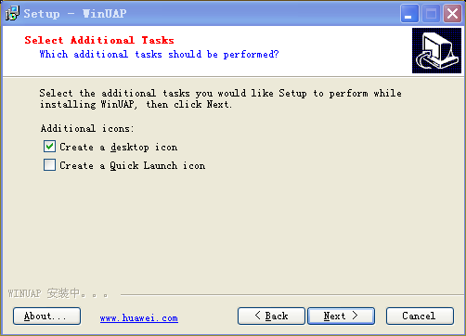

Please select whether to create a desktop shortcut and quick launch bar items. Continue the installation by clicking "Next", click "Cancel" to exit the installation, go back and click the "Back"

Huawei, click the "About" button for more information click on the "www.huawei.com

If you need to create Desktop shortcuts and Quick Launch bar item, check the corresponding check boxes.

### Ready to Install

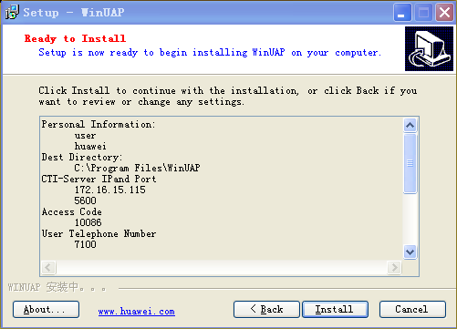

Display the user setup information, continue the installation by clicking Install. To exit the installation click "Cancel" .To return to the previous step click the "Back"

Huawei, click the "About" button for more information click on the "www.huawei.com

Here you can view your setup information, such as the need to change, click the "Back" to the corresponding installation page to modify.

### Installation

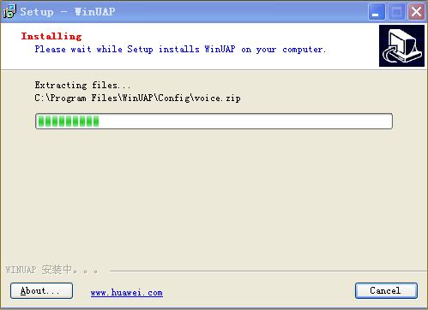

The installation process may last for a few minutes, please be patient! If you want to terminate the installation click "Cancel"

Huawei, click the "About" button for more information click on the "www.huawei.com

### The end of the installation

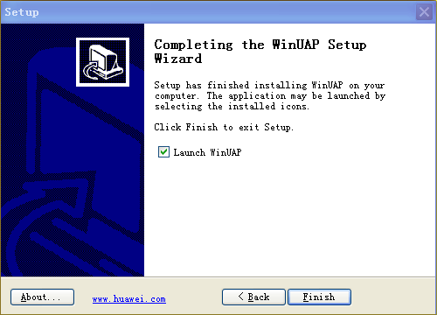

To exit the installation click "Finish”, Go back and click the "Back", Run immediately Win UAP, check the "Launch Win UAP."

Huawei, click on "About "button, for more information click on the" www.huawei.com

## Second, theFrequently Asked Questions

### How to modify the configuration after installation is complete?

After the installation is completed we can modify the content by logging into the command line. As shown below:

* To modify the System-MID:

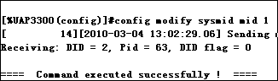

The above==== The Command executed successfully! ====, successfully modified

* To modify the CTI-Server IP and the port:

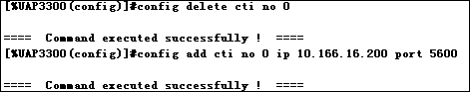

* To add a new Access Code:

Ibid., at the command line, enter:

config add prefix dn 10086 callcategory intess callattribute inter cldpredeal no minlen 1 maxlen 24

* To add userPhone-Number in batch :

Ibid., at the command line, enter:

config add batch sipue seid 7100 authorizationtype noauth number 10

config the add subscriber eid 7100 dn 7100 number 10

config add prefix dn 71 callcategory basic callattribute inter cldpredeal no minlen 1 maxlen 24

Note: here prefix "And" Access Code has the difference, The prefix added here is for basic call, call between the two phone numbers if phone number starts with 55 like 5500, 5501 then add a prefix “55”.

### How to use Openeye Sign InWINUAP?

In Openeye, for login enter the phone number. (For example, the configuration7100 ~ 7109),

Note: The server address in the "Advanced Settings" you need to set the UAP IP Address before logging in.

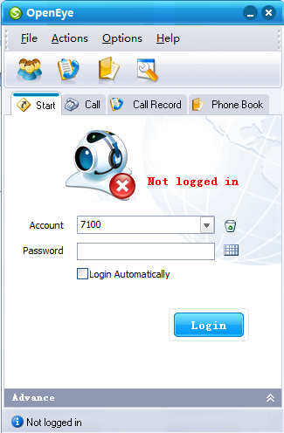

### How to use WIN UAP Release the audio function?

After logging in, as shown below, click on the drop down and choose audio. 

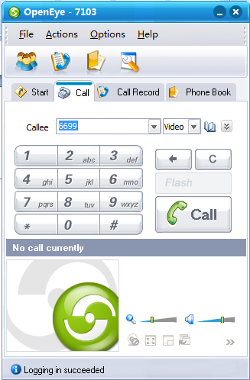

### If you are using WIN UAP Video capability?

After logging in, As shown below, Click on the mapTriangular arrows in the diagram, select the video to select the input* 125, The system will be voice and video broadcast digital7103(Specific content is broadcast according to the number you are logged), can also enter the installation configuration the access code, The system will play you in the IVR Set of files in the process! On IVR Specific settings see "WINUAPProducts. Doc".

Note: Need to add the appropriate access code, you can logCTIThe "webConsole functions to modify specific changes can be found inTopEng-Intelligent Call CenterWASSystemInstallation Guide(V300R004C01B16x_02). Pdf"

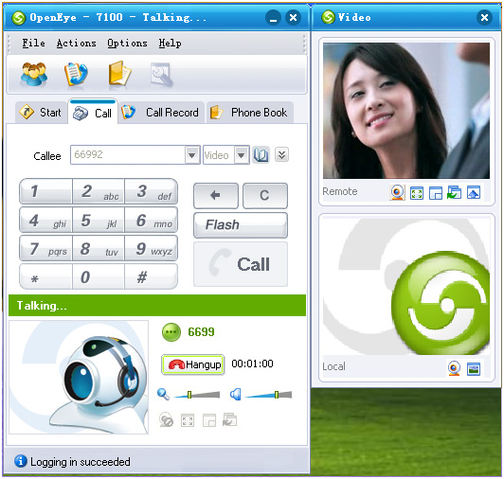

# WindowsVersionnfsFile server Installation and Configuration Guide

## First, the installation environment requirements

Preparation for installation windows 2000 server or 2003 server Server, then install Windows Service for UNIX 3.5 Program, the program Microsoft The official download.

TO Check the NTFS follow the below steps:

1. Select [Start/My Computer].

2. Select the drive you want to install Windows Service for UNIX

3. In the right click select "Properties", check whether in General tab NTFS. (If not, you need to reformat or use tripartite tools to turn the partition format)

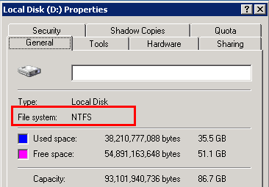

## Second, theThe installation process is as follows:

1. Run the installation disk Setup.exe, the system displays the Setup Wizard, click <Next>To enter the user information input interface.

2. Enter the user name, where the sector, click <Next> to entry permit management interface.

3. Select the "I accept the agreement” box, click <Next>, enter the installation type selection screen.

4. Select the "Custom Installation” selection box, click <Next> into the file selection interface.

Click unwanted options before In the pop-up menu select "Entire feature will not be available. "

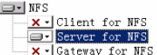

● Select User Name Mapping and Server for an NFS Authentication.

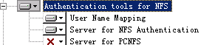

Note: Recommended to customize the way, otherwise, the installation time it takes slightly longer.

6, Click <Next> Into the security settings interface, no need to select, click<Next>To enter the configuration map server interface.

7, Select the "Local User Name Mapping Server” box, and then selected by Password and the group files , click<Next>, Set the interface into the local user name.

8,"Password the file the path and name "Group file path and name" Specified passwd And group where the path needs to be configured, click<Next>, Enter the installation directory selection interface.

9, Select the file system as NTFS the path to where the format of the catalog letter, click<Next> after the system start the installation.

10After the installation is complete, pop the installation is complete the interface, click<Finish>Installation is complete

## Third, theNFSThe file server configuration:

1, Document preparationWill rar Unzip the file server (whatever directory)



Map A

2 To open nfs, for unixTool, select User Name Mapping, According to the figure password and group Import (these two files in the first rar package)



Map2

3, As shown in Figure2 And Figure3 Settings, complete the user the map configuration Finally, save the configuration, nfs Configured.



Map3

4, Should be noted that,windows2003On directory access rights. Directory access permissions need to be set in the following diagram.

Mapped Windows group or user must have read or write permissions to the NFS shared folder, so that the NFS client to the folder to read or write.

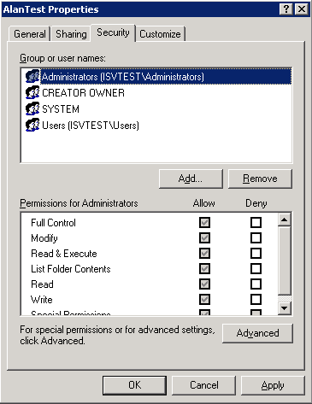

Map4

## Four, OpenNFSShared Services

To share a folder, right click and choose to share. Click<NFS Sharing> Tab, set the following details in the diagram.

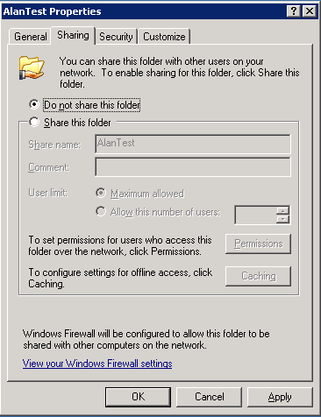

NFSConfiguration

Note1: One share is the share name, and when the need to use the file server to do path mapping. This share name must be all Lowercase letters of the alphabet. If To share is changed, then bmrs cannot be connected.

Note2: The blue part of the certified parts, namely ,user ID And group ID We need to change65534And65533, Followed by BMRS Configuration NFS will be used. Finally, click "Permissions" Button, jump out of the read-write property configuration, select "Read-Write, Keep the default settings.

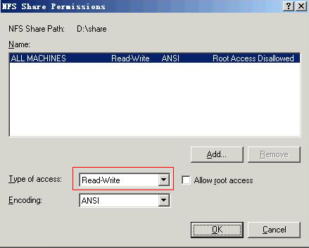

**5, Install the file server that points**

Install the file server PC Local. Registry should be used administrator. User login and user password cannot be empty, because of the WINDOWS2003 system's security requirements.